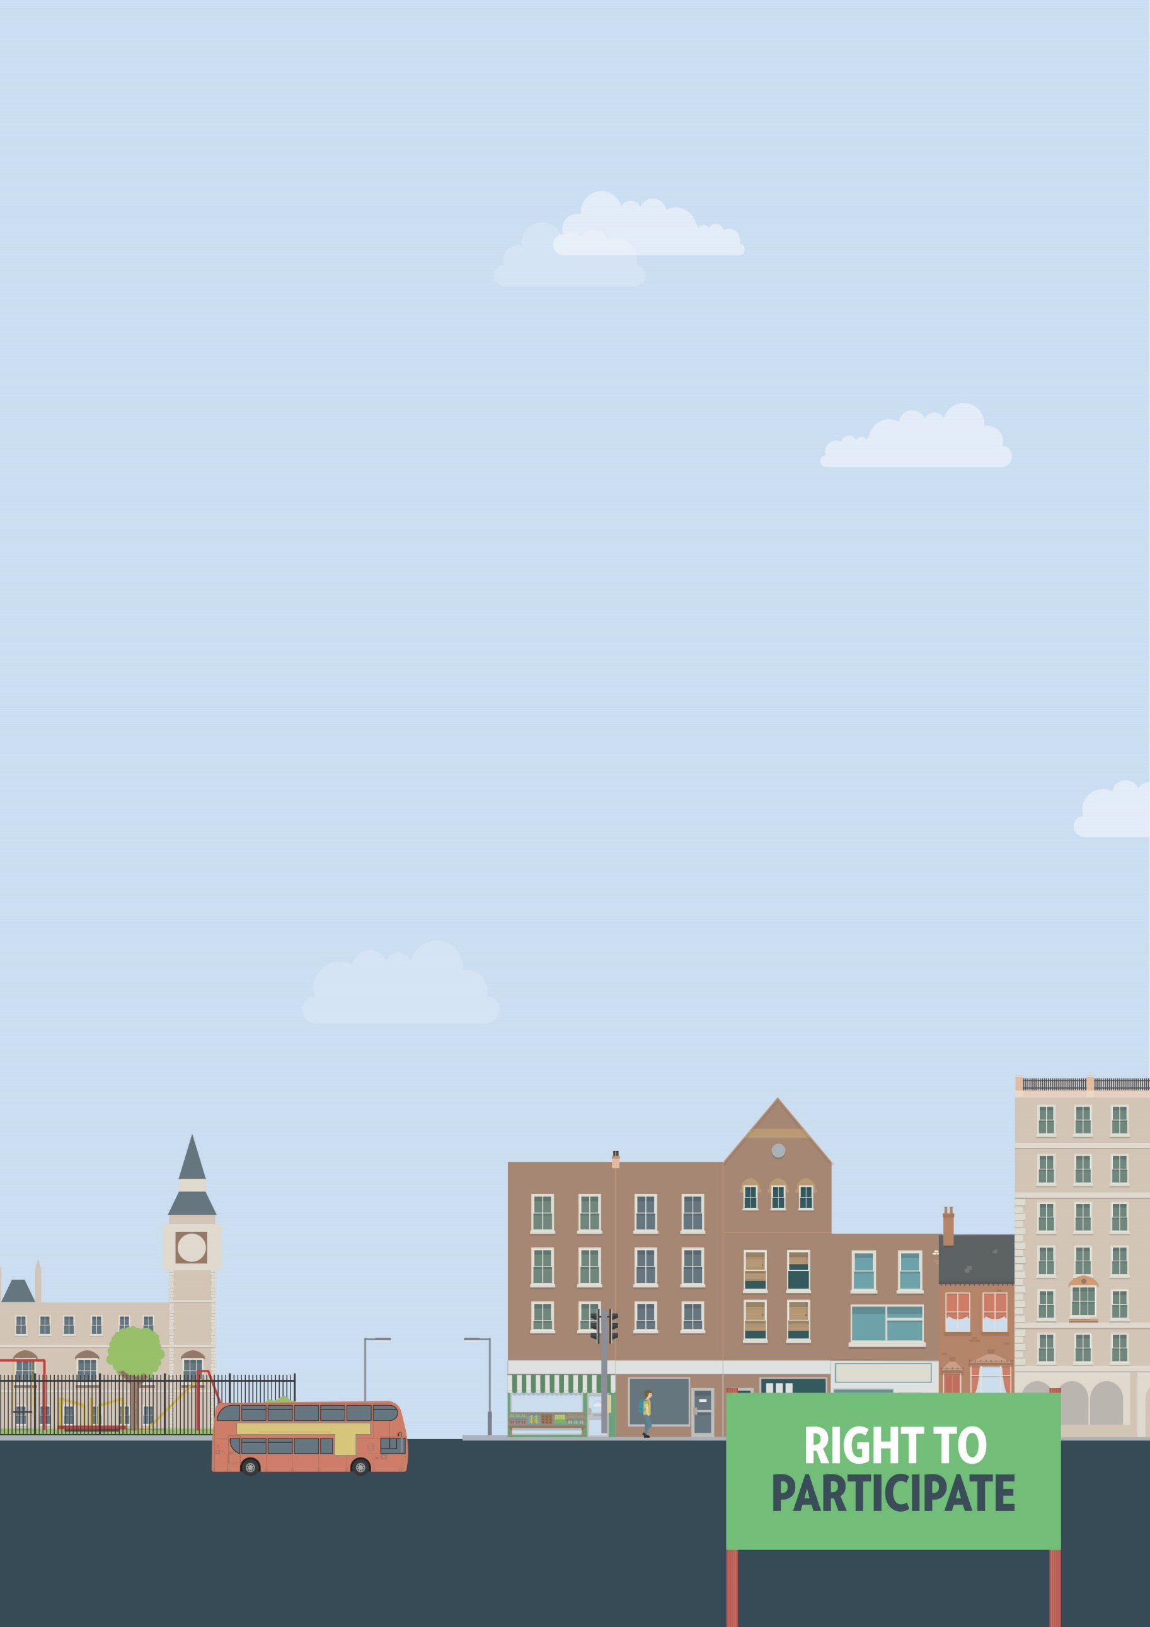
Museums, art galleries, amusement parks
Concessionary tickets and support workers
Out and about

Useful knowledge
The Equality Act 2010 requires service providers, including shops, pubs, restaurants, art galleries, museums and theatres to make reasonable adjustments, if asked, to ensure that disabled people can use those services.
This can include providing additional support or assistance, providing a ramp to ensure wheelchair access, or making information available in alternative formats, such as braille or easy-read.
If you need reasonable adjustments that do not appear to be available, you will have to ask for them yourself. However, the Equality Act also requires service providers to think ahead and develop adjustments they think disabled people using their services are likely to ask for. Failure to make reasonable adjustments, particularly when you ask for them, is a form of discrimination.
Speaking to or writing to the owner or manager of a service is often the best way to ensure your access needs will be met. If you know what kind of adjustments you need, it is usually easier to get them implemented.
Museums, art galleries, amusement parks
Under the Equality Act service providers have an obligation to ensure disabled people can access a service or an event at no greater cost than a non-disabled person. If you require one-to-one support to access a museum, art gallery or amusement park, you should be able to request a ticket for your support worker at a discounted rate, or even no charge at all.
Some places may ask for evidence of a disability, the kind of evidence required can vary. It may include a letter from your GP or a letter indicating you receive Personal Independence Payment (PIP) - although receiving PIP doesn’t itself mean that you have a disability for the purposes of the Equality Act. Cards like the Access Card or a disabled person railcard are also accepted by many places, and some may not ask for any evidence at all.

Useful skills
- Effective communication
- Negotiation skills
- Problem solving
Ways to assert your legal rights
- If you require one-to-one support to access a museum, art gallery or amusement park, and your supporter is not allowed a discounted or free ticket, your rights may have been violated under the Equality Act. Contact the organisation that manages or owns the art gallery, museum or amusement park and inform them how the lack of access to concessionary or free tickets for your supporter prevented you from accessing a space or activity or created disproportionate financial cost for you.
- If you’re not satisfied with the response, you can take them to court. You should seek legal advice before doing this. There are strict time limits for taking legal action under the Equality Act. You have six months minus one day from the date of discrimination to make your claim in the County Court. A court can allow a claim out of time in limited circumstances. You can claim for compensation, and a legal order for the service provider to make the reasonable adjustments you had asked for but been refused.
In some cases, you have to tread lightly. Some places believe that they have to provide free tickets, others not. You don’t want them to think that they don’t have to!
Claims have been brought against organisations that have not provided discounted tickets – it is arguable under the Equality Act 2010, depending on the circumstances.

You can get more help from
The Equality Advisory & Support
Service (EASS) runs a free helpline assisting individuals with equality and human rights issues across England, Scotland and Wales.
Telephone
Text phone
Email
0808 800 0082
0808 800 0084
through websites form

