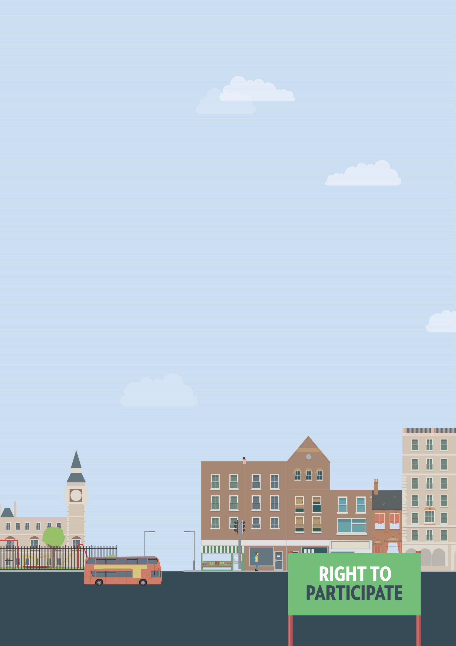
Museums, art galleries, amusement parks
Buildings or spaces not accessible
Out and about

Useful knowledge
The Equality Act 2010 requires service providers, including shops, pubs, restaurants, art galleries, museums and theatres to make reasonable adjustments, if asked, to ensure that disabled people can use those services.
This can include providing additional support or assistance, providing a ramp to ensure wheelchair access, or making information available in alternative formats, such as braille or easy-read.
If you need reasonable adjustments that do not appear to be available, you will have to ask for them yourself. However, the Equality Act also requires service providers to think ahead and develop adjustments they think disabled people using their services are likely to ask for. Failure to make reasonable adjustments, particularly when you ask for them, is a form of discrimination.
Speaking to or writing to the owner or manager of a service is often the best way to ensure your access needs will be met. If you know what kind of adjustments you need, it is usually easier to get them implemented.

Museums, art galleries, amusement parks
Under the Equality Act museums, art galleries and amusement parks must make reasonable adjustments for disabled visitors. This can include modifying premises, installing accessibility equipment, providing seating areas and providing information in alternative formats.

Useful skills
- Effective communication
- Negotiation skills

Ways to assert your legal rights
- If an attraction is unable to provide you with reasonable adjustments you can request them. Speak to a member of staff to see if they have a process for requesting adjustments. If there is no such process, speak to or write to the manager of the museum, art gallery, amusement park, etc. Provide details as to the kind of adjustments you need and ask about the timeline for providing them.

Download complaint letter

You may also want to consider seeking injunctive relief
A museum, art gallery or amusement park refusing to make adjustments may not necessarily be discrimination, provided all reasonable attempts have been made to allow access for disabled people. For example, amusement parks have minimum height and weight limits on some rides. Denying you access if you’re below the minimum height would not be grounds for discrimination if the requirement can be shown by the park to be ‘a proportionate means of achieving a legitimate aim’. If the aim is health and safety, it may be legitimate. As long as there is no other less discriminatory way of achieving the aim, other than refusing on height grounds, it will be justified.

You can get more help from
The Equality Advisory & Support
Service (EASS) runs a free helpline assisting individuals with equality and human rights issues across England, Scotland and Wales.
Telephone
Text phone
Email
0808 800 0082
0808 800 0084
through websites form

