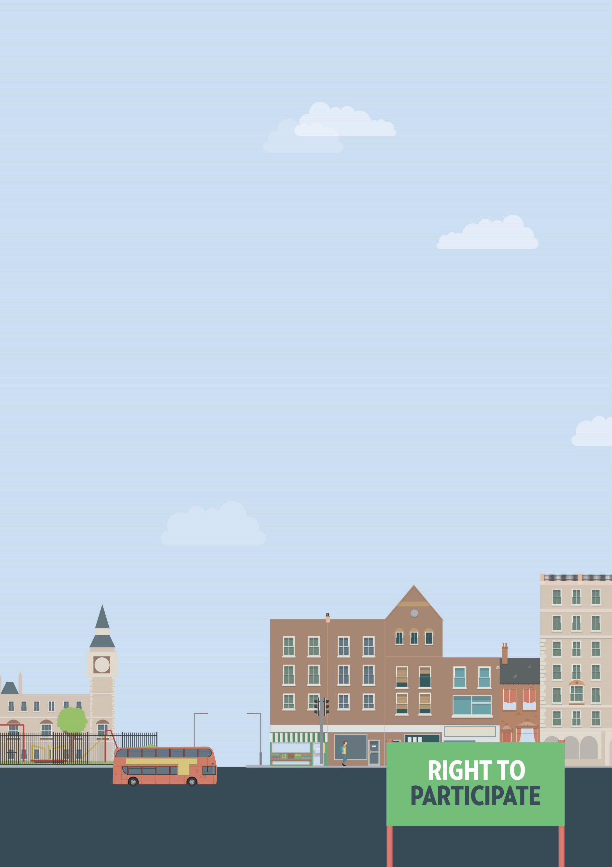
Gyms and leisure
Not accessible to me
Out and about

Useful knowledge
The Equality Act 2010 requires service providers, including shops, pubs, restaurants, art galleries, museums and theatres to make reasonable adjustments, if asked, to ensure that disabled people can use those services.
This can include providing additional support or assistance, providing a ramp to ensure wheelchair access, or making information available in alternative formats, such as braille or easy-read.
If you need reasonable adjustments that do not appear to be available, you will have to ask for them yourself. However, the Equality Act also requires service providers to think ahead and develop adjustments they think disabled people using their services are likely to ask for. Failure to make reasonable adjustments, particularly when you ask for them, is a form of discrimination.
Speaking to or writing to the owner or manager of a service is often the best way to ensure your access needs will be met. If you know what kind of adjustments you need, it is usually easier to get them implemented.

Gyms and leisure centres
Under the Equality Act, gyms, leisure and sports centres must make reasonable adjustments for disabled visitors and members. This can include modifying premises, changes to layout, installing accessibility equipment, providing seating areas, clearer signage and help to use exercise machines.

Useful skills
- Effective communication
- Negotiation skills
- Problem solving
- Decision making

Ways to assert your legal rights
- If a gym or leisure centre is unable to provide you with reasonable adjustments, you can request them. Speak to a member of staff to see if they have a process for requesting adjustments. If there is no such process, speak to or write to the manager of the gym or leisure centre. Provide details as to the kind of adjustments you need and ask about the timeline for providing them.

Download leisure centre complaint letter

You may also want to consider seeking injunctive relief
As part of the duty to make reasonable adjustments, a service provider cannot pass on any costs to a disabled person. So, for example, a gym cannot ask you to pay towards the costs of a hoist.
- If a gym or leisure centre refuses or ignores your request for a reasonable adjustment, they may have breached your rights under the Equality Act. You have six months minus one day from the date of discrimination to make your claim in the County Court. A court can allow an out-of-time claim in limited circumstances, but it is better to seek legal advice first. You can claim for compensation, and a legal order for the service provider to make the reasonable adjustments you originally asked for.

You can get more help from

Disability Rights UK
Get Yourself Active project working with the health, social care and sports sectors to develop better opportunities for disabled people and promoting the use of personal Budgets for physical activity
Get Out Get Active peer support project, for example bringing together an active disabled person to support another disabled person who wants to be more active but is experiencing barriers.
English Federation of Disability Sport (EFDS)
search for facilities which have been awarded
Inclusive Fitness Initiative accreditation.
The Equality Advisory & Support
Service (EASS) runs a free helpline assisting individuals with equality and human rights issues across England, Scotland and Wales.
Telephone
Text phone
Email
0808 800 0082
0808 800 0084
through websites form

