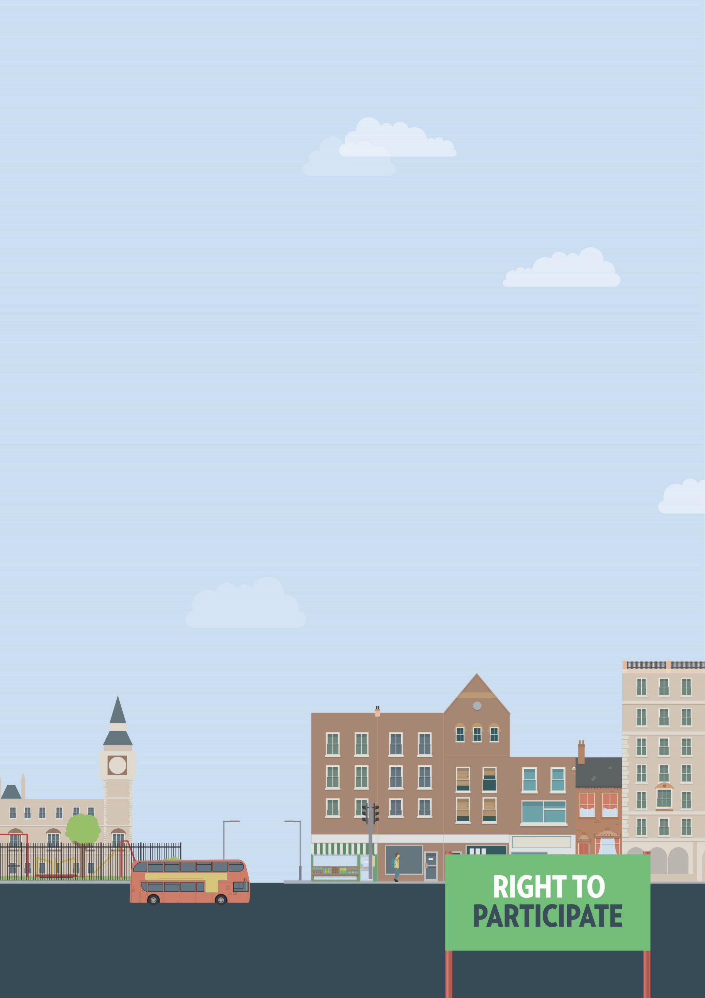
Gyms and leisure
Accessible to me but refused access
Out and about

Useful knowledge
The Equality Act 2010 requires service providers, including shops, pubs, restaurants, art galleries, museums and theatres to make reasonable adjustments, if asked, to ensure that disabled people can use those services.
This can include providing additional support or assistance, providing a ramp to ensure wheelchair access, or making information available in alternative formats, such as braille or easy-read.
If you need reasonable adjustments that do not appear to be available, you will have to ask for them yourself. However, the Equality Act also requires service providers to think ahead and develop adjustments they think disabled people using their services are likely to ask for. Failure to make reasonable adjustments, particularly when you ask for them, is a form of discrimination.
Speaking to or writing to the owner or manager of a service is often the best way to ensure your access needs will be met. If you know what kind of adjustments you need, it is usually easier to get them implemented.
Gyms and leisure centres
Under the Equality Act, gyms, leisure and sports centres must make reasonable adjustments for disabled visitors and members. This can include modifying premises, changes to layout, installing accessibility equipment, providing seating areas, clearer signage and help to use exercise machines.
There may be some circumstances where you could be denied entry to all or part of a space on health and safety grounds. This does not necessarily constitute discrimination, provided all reasonable attempts have been made to eliminate disproportionate risks for disabled people.
However, some gyms or leisure centres may be overzealous in refusing access on the grounds of health and safety. For example, if you’re denied entry because staff assume you won’t be able to safely evacuate in the event of a fire, even though there are adequate means of evacuation, you’re likely to have been discriminated against. Disabled people have the same rights as non-disabled people to take risks. In many circumstances you have a right to decide for yourself how much of a risk you’re willing to accept.
Useful skills
- Effective communication
- Negotiation skills
- Writing clearly
Ways to assert your legal rights
- If you’re denied access on health and safety grounds that you believe discriminated against you, speak to or write to the manager of the gym leisure or sports centre. Provide details on what you were refused access to and why you think the refusal constitutes discrimination.
- If you're not satisfied with the response, you can take them to court. You should seek legal advice before doing this. There are strict time limits for taking legal action under the Equality Act. You have six months minus one day from the date of discrimination to make your claim in the County Court. A court can allow a claim out of time in limited circumstances. You can claim for compensation, and a legal order for the service provider to make the reasonable adjustments you had asked for but been refused.
You can get more help from
The Equality Advisory & Support
Service (EASS) runs a free helpline assisting individuals with equality and human rights issues across England, Scotland and Wales.
Telephone
Text phone
Email
0808 800 0082
0808 800 0084
through websites form

