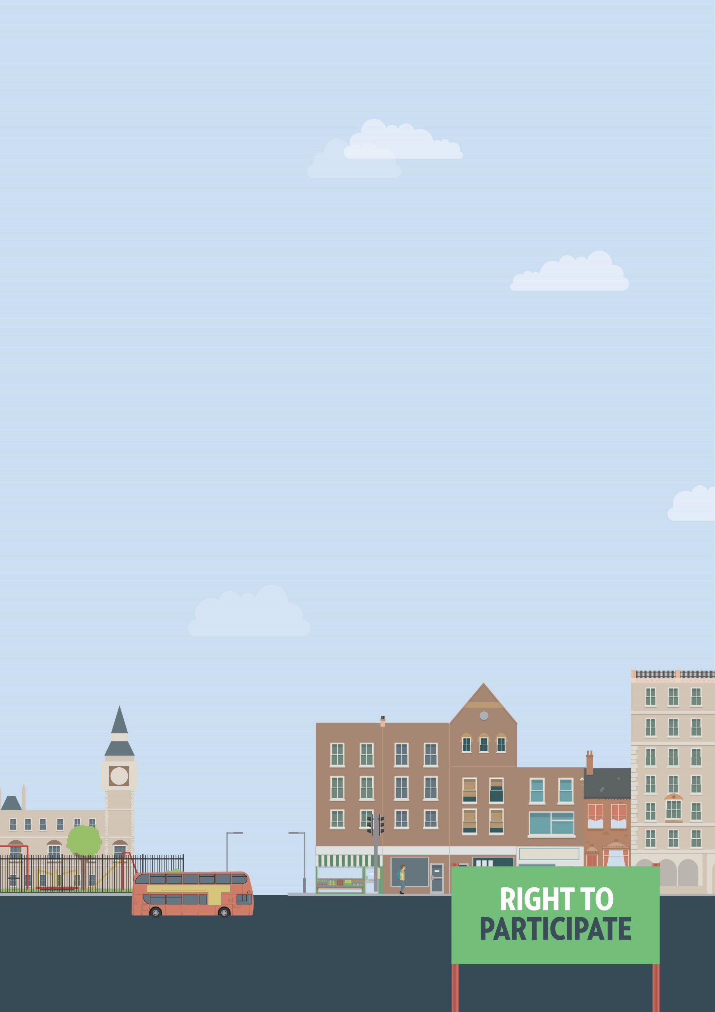
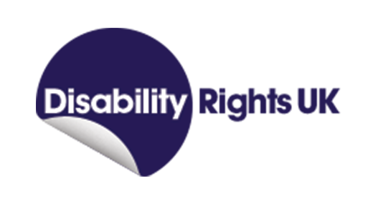
Government services
Information not accessible
Out and about

Useful knowledge
Like other services, government services are covered by the Equality Act 2010. Government services have a particular obligation to be accessible to everyone regardless of disability. For example, in England the NHS Accessible Information Standard is supposed to ensure all information you might need as a patient is available in the most accessible format for you. This can include providing documents as large print, braille, or easy read, or providing BSL interpreters. It also means that services must be provided in various ways. For example, if a service is typically only available over the phone, you have the right to access it through other ways such as email or internet chat.
Useful skills
- Effective communication
- Negotiation skills
Ways to assert your legal rights
- If a government service is unable to provide you with necessary information in an accessible format, contact the department responsible. Provide details as to the kind of alternative format you need and ask when the format will be made available to you.
- If a government service refuses or ignores your request for an alternative information format, they have likely breached your rights under the Equality Act 2010. You have six months minus one day from the date of discrimination to make your claim in the County Court. A court can allow an out-of-time claim in limited circumstances, but it is better to seek legal advice first. You can claim for compensation, and a legal order for the service provider to make the reasonable adjustments you originally
asked for.

You can get more help from
The Equality Advisory & Support
Service (EASS) runs a free helpline assisting individuals with equality and human rights issues across England, Scotland and Wales.
Telephone
Text phone
Email
0808 800 0082
0808 800 0084
through websites form

