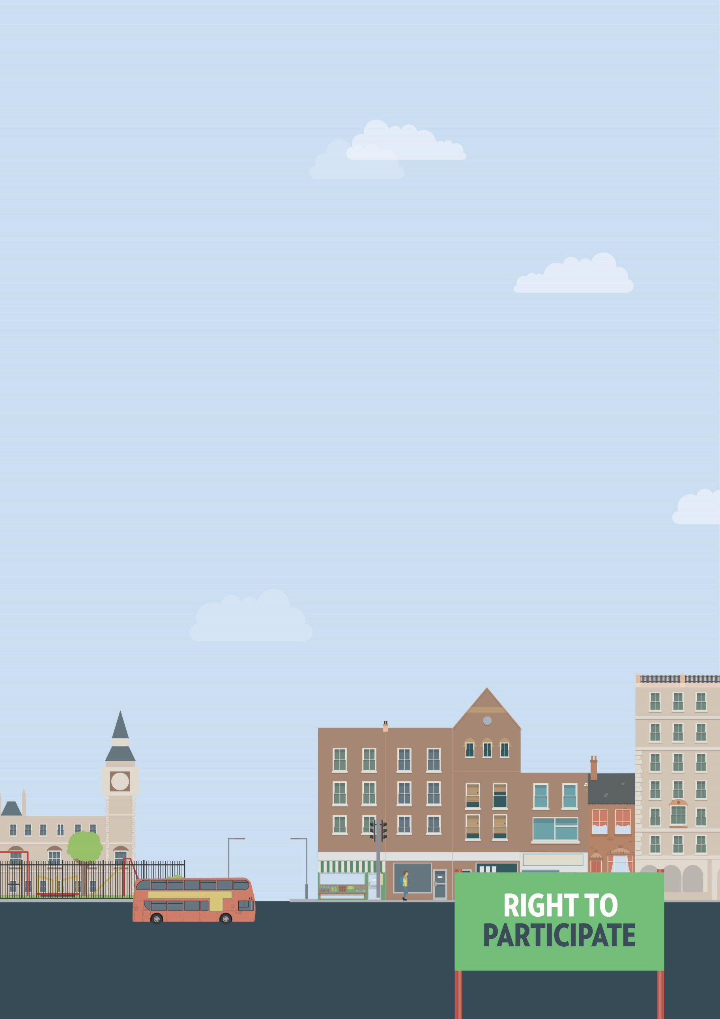
Government services
Buildings or spaces not accessible
Out and about

Useful knowledge
Like other services, government services are covered by the Equality Act 2010. Government services have a particular obligation to be accessible to everyone regardless of disability. Government buildings must take reasonable steps to ensure access for disabled visitors. This can include modifying premises, installing accessibility equipment, providing seating areas and providing information in alternative formats.

Useful skills
- Effective communication
- Negotiation skills
- Writing clearly

Ways to assert your legal rights
- If you’re unable to access a government building, you can request support or adjustments to allow you access. Speak to a member of staff to request adjustments. If they cannot provide reasonable adjustments, contact the department responsible. Provide details on the kinds of support and adjustments you need and ask how long it will take to put them into place.

Download government service complaint letter
- If a government service refuses or ignores your access request, they may have breached your rights under the Equality Act 2010. You have six months minus one day from the date of discrimination to make your claim in the County Court. A court can allow an out-of-time request in limited circumstances, but it is better to seek legal advice first. You can claim for compensation and a legal order for the service provider to make the reasonable adjustments you originally asked for.

You can get more help from
The Equality Advisory & Support
Service (EASS) runs a free helpline assisting individuals with equality and human rights issues across England, Scotland and Wales.
Telephone
Text phone
Email
0808 800 0082
0808 800 0084
through websites form

